First Name last name
Nørregade 7B, 1165 Copenhagen K · +45 12 34 56 78
Name.lastname@mail.com linkedin.com/in/firstlastname Twitter/Blog/Portfolio
A highly structured, motivated and responsible business development graduate offering 2 years of experience and a proven track record in penetrating new markets and building new client relationships through cold calling. I´m looking to develop my skills within communication, sales and market research even further, while hunting for new business opportunities for Copenhagen Capacity.

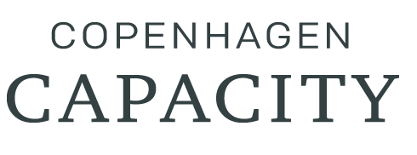

Key COMPETENCIES & Skills
List your strengths relevant for the role your´re applying for. Take a look at the wanted skills listed in the job description and choose those who match your skills/experience. Make sure you list an equal number of skills and include both branch technical skills, “soft” skills and Software skills as shown below. Also remember to weave your skills into your experience section, to show how you leveraged them to achieve each accomplishment.

- Social Media Advertising  - Sales  - Communication  - Analytical | - Team player  - SEO  - WordPress  - Email marketing

Experience

June 2017 – August 2017

sales and business development representative intern, Smiles
Describe your responsibilities and achievements in terms of impact and results.
Use examples, but keep it short ie;

- Conducted market research to develop pricing strategy
- Developed my own sales technique through cold calling using finely honed communication and negotiation skills to foster new client relationships
- Participated in sales meetings and pitched ideas for new business for the
- Management group
- Improved Spanish skills throughout internship period, from limited working proficiency to full professional proficiency
- Chosen as summer intern out of 120 applicants for internship at Smile´s HQ in Barcelona

Oktober 2015 – June 2017

Business development assistant, Business Inc.
Describe your responsibilities and achievements in terms of impact and results. Use examples, but keep it short.
- Identified new potential prospects through market research
- Tasked with generating new product sales through cold calling to foster new relationships
- Maintained client relationships with existing client base

EDUCATION

september 2015 to may 2017

MsC Business Development and innovation, Business School, Denmark
- Achieved grade on Master Thesis; 12
- Chosen as summer intern out of 120 applicants for internship at Smile´s HQ in Barcelona

August 2012 to June 2015

Bsc International business, University, Germany
- Awarded for best case solution in Companies case competition 2014
- The BSc International Business covers three main areas: Economics, business economics and management, and methodology

LAnguages
Use this section to show your language skills. You can also choose to showcase your skills by using Graphics.
- German; Native proficiency  - English; Bilingual proficiency | - Spanish; Full professional proficiency  - Danish; Elementary proficiency

Activities
Use this section to highlight your relevant passions, activities, and how you like to give back. It’s good to include Leadership and volunteer experiences here. Or show off important extras like publications, certifications, languages and more.

